Bug_01:

On members Detail
Bug_02:
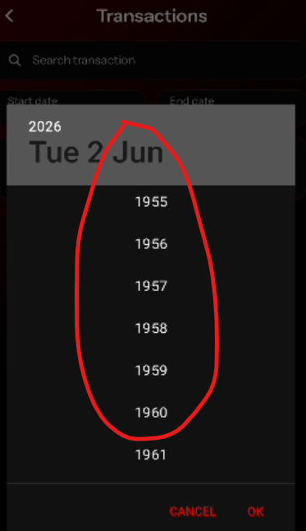

Bug_03:
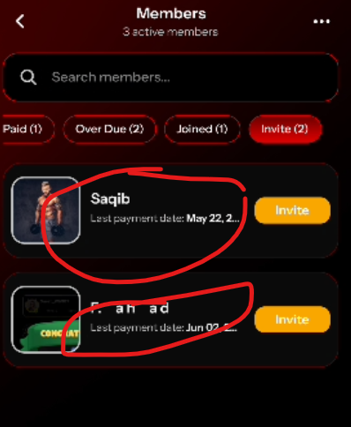
Stills shows the users in invite section when they already joined
Bug_04:
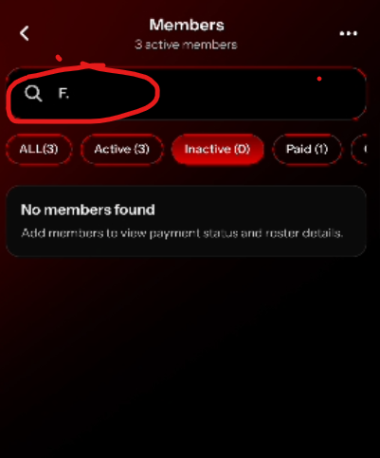
When coach search for specific user and then go to Home Page then click on Member Page the Search Bar should b clear.
in complete app
Bug_05:
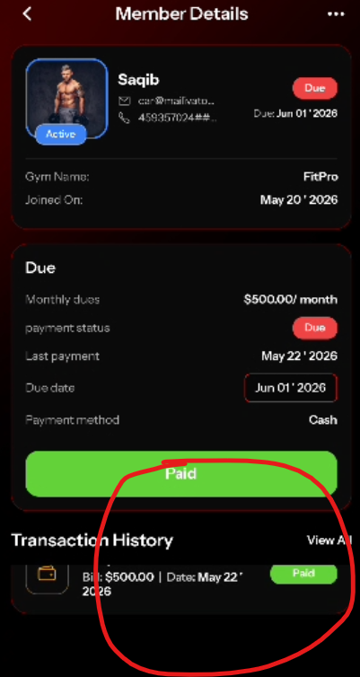
Scroll issue
Bug_06:
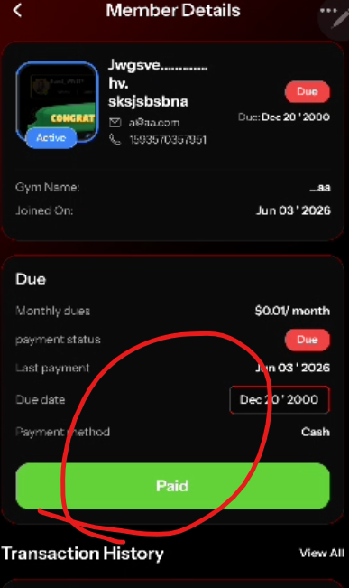
Payment issue
Bug_07:
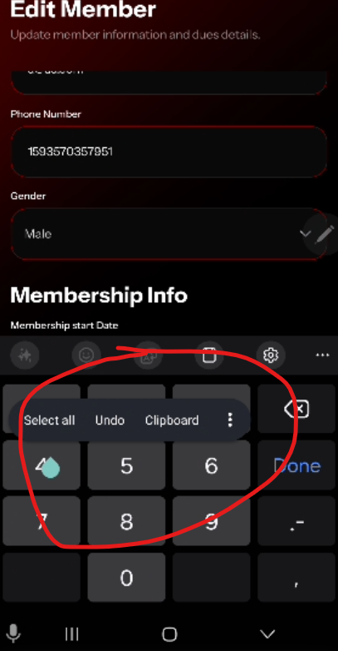
Select the monthly dues, then scroll up. The keypad and select section overlap
Bug_08:
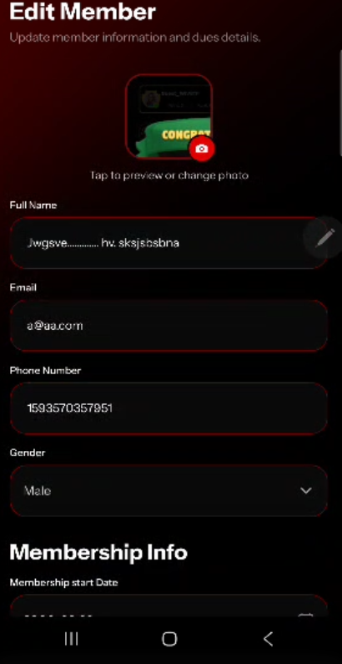
When user edit the member info and before click on save, click on back button. It should ask cancel the save changes or not.
Bug_09:
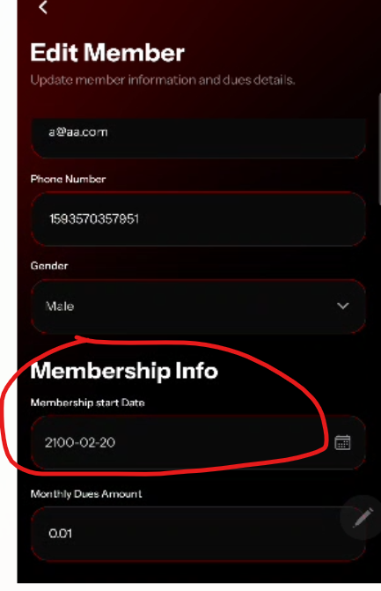

Membership Start Date Field should be disable and not visible

